**Plasma Donor Application**

**Abstract:**

* If somebody need a plasma donor, this system is employed. Both the administrator and the user of this system have the ability to request a plasma.
* A user who is an active member of the app and who has recovered from any ailment or disease is referred to under this system as an active user.
* The request might be accepted or rejected by either party.
* To donate plasma, a person must first register in our application by entering the necessary details, such as name, age, plasma group, phone number, and location..
* Patients who require plasma can fill out the form as well. Patients can call donors directly by getting their contact information from the application.
* Utilizing the network of their phone, the user may also do a search depending on the area they now reside in in order to connect with individuals who can meet their needs for plasma.
* Anyone can find the greatest number of plasma donors in the shortest amount of time, and that too within just 5 kilometres of where the plasma is needed, with just one search.
* Also saves plasma donation history, to increase the possibility of saving lives.

**Novelty:**

A new technology called cloud communication can be utilised in conjunction with conventional health management to deliver improved health care. Personal and public healthcare services, as well as education and research initiatives, are the key components of traditional healthcare systems. Hospitals, residences, and other facilities offer personal healthcare services. Guidelines for medications, foods, and safety procedures are part of public healthcare services in order to maintain a healthy environment. For the prevention, identification, monitoring, and treatment of illnesses, teaching and research efforts are crucial. Today's healthcare information systems are created with the user in mind, who benefits from their ease. Many emergency scenarios call for particular plasma in an urgent manner. Medical advancements have raised the demand for plasma in numerous ongoing therapies and medical procedures outside of emergency situations. We have created an application to address every issue that the current offline and online methods have in order to encourage individuals to donate plasma and assist patients obtain plasma in urgent situations. Using this programme, we will be able to get in touch with Blood/Plasma Banks, Hospitals, and individual registered Donors if a patient needs plasma in an emergency. Lack of plasma resources, particularly in developing nations like India, is a barrier to other people's ability to live. This algorithm also takes into account the donor's desire and proximity to the location where the call is originating from. The algorithm is used to identify the best qualified donor.

# Feasibility Of Ideas:

**Admin:**

Both donors and acceptors can be managed by the admin. Any user can be added or removed from the system by him. Each participant in a donor & acceptor is given a user id and password that uniquely identify him. You may modify the donor details in the admin module.

delete donor or change the password.

· Change Password

· Modify donor details

· Delete donor details

· Logout

**Login:**

The system requires users to register before they can log in. The user can connect in to the system as a Plasma Donor after successful registration.

**Acceptors:**

This module aids the user in locating a plasma group. The system prompts the user to input the plasma group he wishes to look for when he clicks on "Find a Plasma Group." After inputting the plasma group, the computer searches for its availability and displays a list of donors who share that plasma group. The change password option is available to users whenever they wish to update their passwords. The system will then prompt the user to provide their previous login and password before checking their information and changing their password. The user can log out of the system by clicking the logout button.

# Business Model:

People in need of plasma can browse our website for information about donors in their city or present location who belong to the same plasma group. They can immediately search for a donor and choose the recipient's required plasma group as well as the name of the city. He then receives information about the city's donors and the same plasma that he has chosen. The warning "SORRY DONORS ARE NOT AVAILABLE WITH THE FOLLOWING PLASMA GROUP AND AREA" appears if no match was identifiedfor the city and group he chose.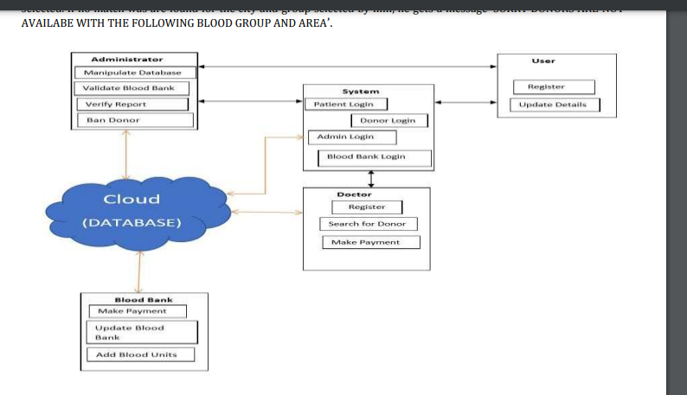

# Scalability:

The goal is to create an enhanced Lifesaver E-Plasma Donation App using the cloud that will aid in bridging the gap between plasma banks, plasma donors, and patients. To create an Android application with capabilities like geo-tagging, SMS Gateway, and payment gateway that can assist people in receiving plasma in emergency situations like as natural catastrophes. We have created an application to address every issue that the current offline and online methods have in order to encourage individuals to donate plasma and assist patients obtain plasma in urgent situations. Using this application, we will be able to contact plasma banks and hospitals in an emergency as well as seek assistance from specific registered donors.